(2024). New Zealand Journal of Music Therapy, 22, 46-49.
© Music Therapy New Zealand

Book Review
Art Therapies in International Practice: Informed by Neuroscience and Research (2022)
Edited by Caroline Miller and Mariana Torkington (Routledge)
Reviewer: Renata Kuswanto
BMT, MT-BC, NZRMTh, Neurologic music therapist
Southern Music Therapy, Christchurch, New Zealand
Correspondence: renata@smt.nz
Citation
Kuswanto, R. (2024). [Review of the book Art therapies in international practice: Informed by neuroscience and research, edited by C. Miller & M. Torkington.] New Zealand Journal of Music Therapy, 22, 46-49.
Music therapy and art therapy are both specialised and developing professions which share the commonalities of the innate human need to express and create relationships with each other. In my clinical experience as a registered music therapist, I note there are some studies exploring the integration of other art therapies modalities such as dance/movement therapy, fine art, and drama therapy with music therapy, but the application of such integration is less well documented. Gilroy and Lee (1995) introduced the idea of integrating art therapy and music therapy and highlighted the need for more research and deeper rationale to chart the development of art therapies over the years. Additional neuroscience-informed practice and research would indeed create potentials for more collaborative work between art therapy modalities to increase therapeutic efficacy.
The terminologies of art, art therapy, and art therapies can be intertwined when different forms of art tools are incorporated. When defining art therapies, the volume Art Therapies in International Practice: Informed by Neuroscience and Research prefers to categorise expressive art modalities used in therapeutic settings under the term “art therapies.” By this they mean that drama therapy, art therapy, dance therapy, and music therapy share the same concepts of using creativity to enhance the therapeutic relationship.
The main editors of this volume are Caroline Miller, a drama therapist and clinical psychologist, and Mariana Torkington, a registered art therapist. Both Miller and Torkington are based in Aotearoa New Zealand and actively contribute to academic journals and publications, supporting the development of art therapies across the country. Miller’s previous publication Arts Therapists in Multidisciplinary Settings (2015) was also a collection from art therapies’ authors, with a focus on art therapy professionals working in multidisciplinary teams, delivered through a series of case examples. Compared to the previous volume, this most recent volume is highly discipline-focused, comprising eleven chapters written by art therapies professionals from New Zealand, Australia, Malaysia, USA, Singapore, South Africa, and the UK. Included are clinical case reviews and honest personal reflection on the implementation of drama therapy, art therapy, music therapy, and dance therapy in addressing a range of therapeutic goals.
The compilation was initiated during the COVID-19 period in 2020-2021 and became a source of support among art therapy professionals, encouraging and affirming each other’s works during the crisis while maintaining the continuation of evidence-based practice. The main theme of the book is to explore the significance of neuroscience-informed rationale in the therapeutic process of developing trust and safety within the parameters of each therapy. A neuroscience approach could be seen, for instance, in chapter 10 where Palmer’s discussion was underpinned by the concept of the mirror neurons system and mechanism to increase the therapeutic relationship and empathy in the practice of community dance therapy. In chapter 3, Dunne and Madrigal adopted the neurobiological approach of understanding internal biochemical processes and observable physiological changes during the process of Narradrama as Three Act Play (NTAP).
The foreword was presented by Noah Hass-Cohen, whose early publications focused on creating a theoretical framework for art psychotherapy and the neuroscience approach in art therapy clinical practice. One of Hass-Cohen’s publications was cited by other contributors in this volume (chapter 5) marking the importance of her contribution in the field. The foreword gave a structure and preview of how neuroscience research is significantly connected and utilised in every form of creative art therapies as they target and activate different parts of the brain at the same time. Hass-Cohen’s presentation of the intersection between neuroscience and psychodynamic theory was helpful as this is a common theme throughout the volume, also outlining the book’s approach with quantitative data predominantly presented as evidence.
In further support of Hass-Cohen’s foreword, Miller highlights that creative processes used by art therapies induce brain development, stimulate the senses, and trigger changes in the nervous system (chapter 1). She states that the intention in exploring neuroscience research in art therapies was to “provide rationale, offering the possibility of targeting parts of the brain, helping with measuring changes of behaviours” within the scope of practice (p 18). In a music therapy context, a Neurologic Music Therapy® theoretical framework is one of the most effective approaches to provide rationale for the effect of music on the brain. Some authors in this volume elaborated on the neuroscience framework in their therapeutic process, including registered music therapist Alison Talmage discussing the work with communication for adults with neurogenic difficulties (chapter 8). Sian Palmer took another neurologic perspective utilising the concept of mirror neurons in dance therapy (chapter 10). Kim Hau Pang used a client-centred approach that was underpinned by neuroscience and neurobiology models in a hospice setting (chapter 6).
By presenting different modalities and perspectives on art therapies, this volume provides rich insights into what type of neurologic-based knowledge each contributor was targeting. This is highly beneficial for practitioners, offering many possibilities for them to integrate art modalities to target different domains of the brain, whether it is memory recall, behaviour changes and observations, or functional purposes such as communication.
When reading through the chapters, readers may find that trauma-based caseloads dominate the volume with approaches gravitating towards a psychoanalytic framework. Initially, I was hoping to explore extensive neuroscience theories in relation to which part of the brain was affected during certain experiences in Narradrama, dance therapy, music therapy, and art therapy. As I read through each chapter, I could see how neuroscience and neurobiology aspects are linked to trauma exposure, especially how they could be used in art therapies to establish a safe space and trusting therapeutic relationship (Oberle et al., 2021). In Aotearoa New Zealand, trauma-informed practice and care has been implemented to support not only the wellbeing of affected individuals, but also the whānau (family) and the community, which requires a certain degree of trust and security to extend the therapeutic relationship (Te Pou, 2021).
The format of the volume highlighted the importance of utilising research and neuroscience models in art therapies practices. I appreciated the use of sample images that were incorporated to support the case studies and evidence. The book presented diverse perspectives, with contributors from different continents and backgrounds. It also showcased holistic or multi-theoretical approaches to clinical practice in art therapy, despite the strong emphasis on neuroscience implied by the title.
Overall, I would recommend this book for all art therapy professionals and other allied health professionals or educators who are seeking non-invasive therapeutic approaches in mental health, neurologic conditions and acquired neuro-rehabilitation settings. This volume invites collaboration between art therapy professionals in neuroscience-informed multi-disciplinary projects, with its diverse multi-theoretical approach. As mentioned in Miller’s final reflection, further collaborative research between neuro-focused professionals is necessary. It is essential to support the expansion of clinical and evidence-based practice in arts therapies.
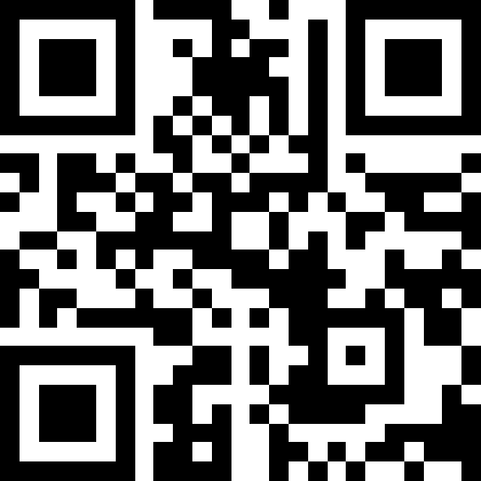
Publisher Link:
https://tinyurl.com/4ey5wt4f

References
Gilroy, A., & Lee, C. (Eds.). (1995). Art and music: Therapy and research (1st ed.). Routledge. https://doi.org/10.4324/9781315812694
Miller, C. (Ed.) (2015). Arts therapists in multidisciplinary settings: Working together for better outcomes. Jessica Kingsley Publishers.
Oberle, A., Postman, W., & van den Berk-Clark, C. (2021). Novel, neuroscience-informed approaches to trauma care in community clinical settings. Missouri Medicine, 118(4), 358–362. https://pubmed.ncbi.nlm.nih.gov/34373672/
Te Pou. (2021). Weaving together knowledge for wellbeing | Trauma informed approaches [Infographic]. https://www.tepou.co.nz/resources/weaving-together-knowledge-for-wellbeing-trauma-informed-approaches

