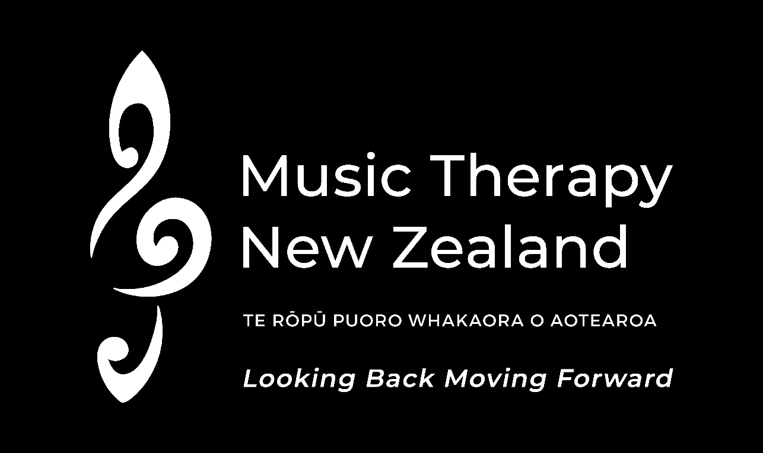



**Special 50**th

**Anniversary Issue of**



***Looking Back Moving Forward***

## www.musictherapy .org.nz

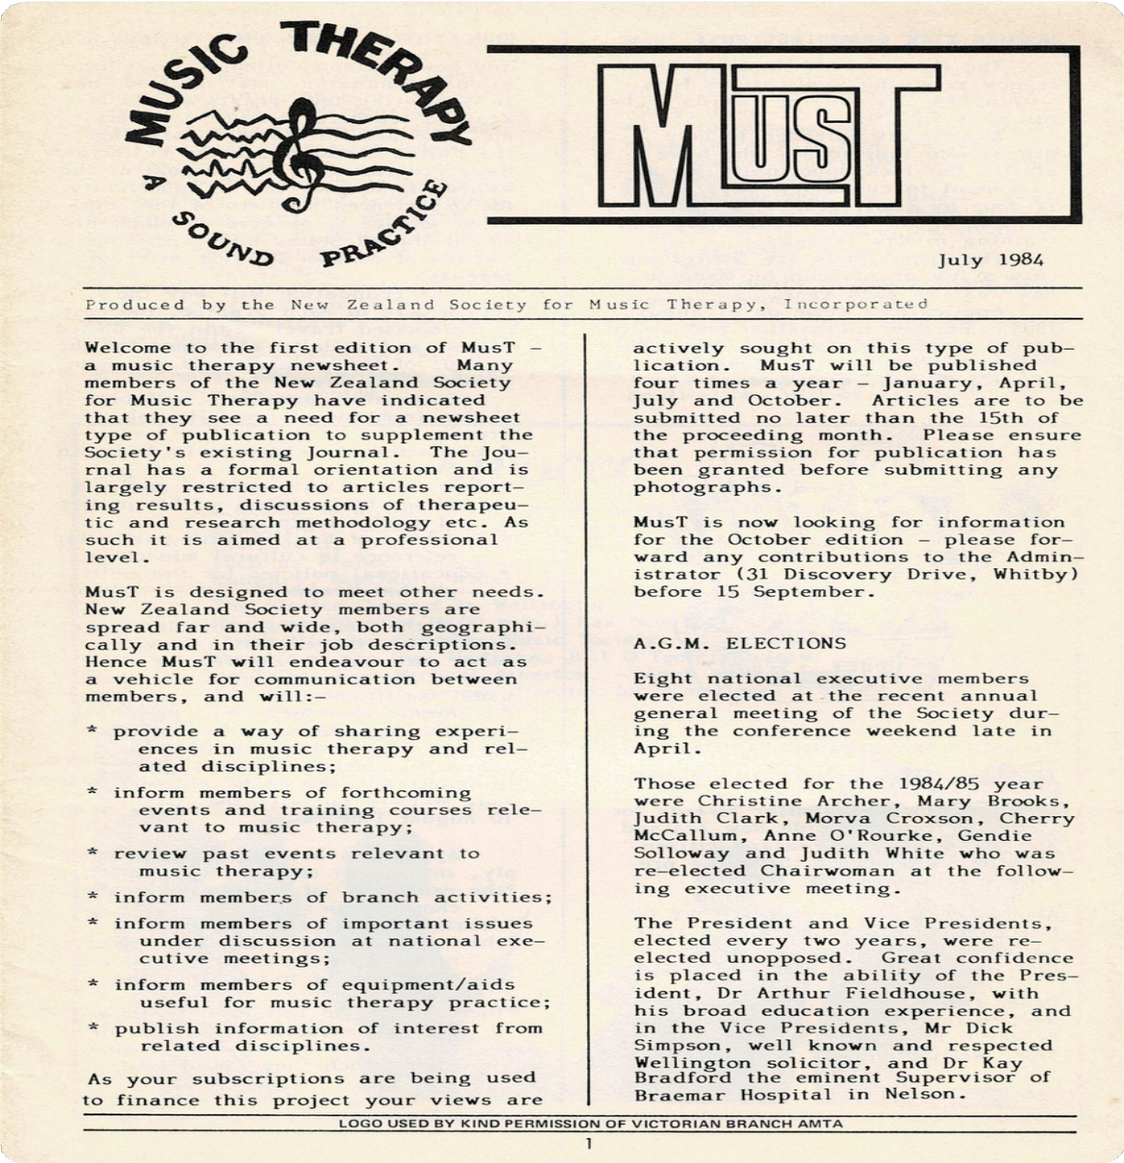

[Click here to view the 1st edition of MusT July 1984](https://www.musictherapy.org.nz/wp-content/uploads/2024/06/1984-MusT-Newsletter.pdf)

# LOOKING BACK MOVING FORWARD

### 13-15 September 2024 - Wellington NZ

It is just over 50 years since those first pioneers gathered to hear Mary Lindgren’s enthusiasm and passion for music therapy. As early as the 7 July 1972 Dick Simpson (life member) wrote to Mary – at that time Mary Worman – and apologised for not having called a meeting which he set for 4pm, 23 July 1972. Fifty-two years ago he invited a small group to his home and this led to the first public meeting on 5 April 1974, attended by 24 people. The rest is history.

And talking about history – on Saturday 14 September this year we will see the launch of a significant book for Music Therapy New Zealand. A History of Music Therapy New Zealand (1974-2023): Passionate People Te Hītori o "Te Rōpū Puoro Whakaora o Aotearoa" (1974-2023):Te Hunga Ngākau Whiwhita. Our own adjunct Professor Dr Daphne Rickson ONZM has spent over a year compiling a full history and the book, published by Barcelona Press, will be launched on this day and a copy will be given to every person who is registered and attending conference in person. It is a significant achievement and provides a rich history of how music therapy has developed in Aotearoa New Zealand and how Music Therapy New Zealand has been at the forefront of this development over the years.

This year the conference is rich and diverse over 60 people presenting 49 sessions from not only New Zealand but also Australia, United Kingdom, USA, Canada, Japan, Singapore, and India. It is also the first hybrid conference that Music Therapy NZ has presented and some presenters will present from their home base and anyone with online registration will be able to watch most sessions live. The full conference (except three workshops) will be available to view for a period of six months after conference for everyone who registers.

GET IN EARLY AND REGISTER NOW

Registration options include attendance in person or online attendance only. All registrants will receive access to an online package of recordings of most conference sessions for a six month period after the conference.

[Early Bird registration closes on 30 July](https://www.eventbrite.co.nz/e/50th-anniversary-conference-looking-back-moving-forward-registration-902957960567)

[Full Registration closes on 26 August](https://www.eventbrite.co.nz/e/50th-anniversary-conference-looking-back-moving-forward-registration-902957960567)

[Online registration closes on 6 September](https://www.eventbrite.co.nz/e/50th-anniversary-conference-looking-back-moving-forward-registration-902957960567)

# LOOKING BACK MOVING FORWARD

### 13-15 September 2024 - Wellington NZ

Music Therapy NZ is also proud to have initiated and progressed the setting up the Master of Music Therapy course at Massey University before it merged with Victoria University to become the NZ School of Music. The course is celebrating 20 years since inception and to mark this significant milestone the opening for the 50th conference will be a combined event at the prestigious Hunter Council Chamber at Victoria University on Friday 13 September.

MThNZ’s weekend conference, Saturday and Sunday, 14 and 15 September, will be held in downtown Wellington at the Wharewaka Function Centre. Three conference rooms will be used for each session, and on the Saturday afternoon an additional room will be used for workshops.

The diversity of topics areas can be seen on the programme which will be of interest for music therapists and their professional development but the programme will also be of interest to many allied health professionals and those in government areas developing policy who want to understand more about the nature of music therapy and the rich diversity of people who it can help and support. It is hoped sponsors and philanthropists wanting to support music therapy development will attend and learn how the planned use assists with the healing and personal growth of people with identified emotional, intellectual, physical or social needs.

There is no doubt that presentations will encourage some stimulating conversations and provide networking opportunities with people across New Zealand but also those attending from Australia and beyond. For students it will provide opportunities to learn about the profession and the opportunities for employment that are presented in New Zealand and overseas.

No doubt those opting to attend the dinner will start new friendships and collaborations across the music therapy world, and conversations will abound about innovative techniques and ideas that are shared.

Don’t forget to share information with your colleagues, your employers, your friends and your clients. MThNZ is hoping that the 50th conference is a celebration to remember for many years with the richness and diversity that is being presented.

#### Headshot of keynote speaker Denise GrockeKEYNOTE PRESENTATION SATURDAY:

**Denise Grocke, Australia**

Recollections of the Beginnings of Music Therapy in New Zealand: I am looking forward to celebrating the 50 year anniversary of the New Zealand Society of Music Therapy in September 2024. It was a privilege for me to be involved in the early days, prior to the course being available, to help in the training of the first music therapists in New Zealand via an accreditation scheme.

The National Executive of the NZ Society for Music Therapy organised training intensives over 4-5 days and brought

*Key Note Speaker*

*Denise Grocke*

clinicians from all over the world to teach modules specific to particular conditions, or specific music therapy methods. I came over many times, in 1982, 1984, 1988, 1991 and 1992, then later for conferences in 2001 and 2002. I was involved in the negotiations to establish the course at the Wellington

Conservatorium, Massey University. Over these years I came to know many of the early pioneers of music therapy.

Later I trained in the Bonny Method of Guided Imagery and Music and again visited New Zealand’s shores to be part of the small group developing the method there. We held two combined conferences and supported each other as we began to sow the seeds once again. I remember the dedication of those involved in establishing music therapy in New Zealand. It takes perseverance to create the building blocks for a strong foundation, and the early practitioners did just that, dealing with the nay-sayers and the set-backs and persevering until everything was in place. I am looking forward to sharing these memories and celebrations with you in September.

#### KEYNOTE PRESENTATION SUNDAY:

**Carolyn Shaw, New Zealand**

It is incredibly humbling (and exciting) to be invited as one of the keynote speakers for the MThNZ Conference 2024, ‘Looking Back Moving Forward’, celebrating 50 years of music therapy in Aotearoa. As a post-structural researcher (a fancy way of describing a researcher who dismantles binary thinking and looks critically at how ‘truths’ are formed, power relations, and ethical implications), I have come to understand the complexities of celebration. How we can both celebrate where we have been and seek change.

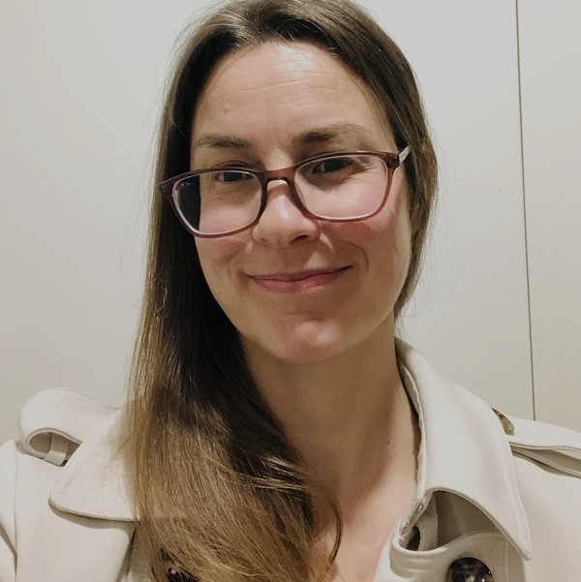

*Key Note Speaker Carolyn Shaw*

Being invited to keynote signals to me the desire to have tough conversations

in the midst of important celebrations – holding space for both things.

As we celebrate 50 years of music therapy in Aotearoa New Zealand, it prompted me to reflect on the developments in music therapy theory, practice and advocacy that move towards more equity and diversity. I am passionate about dismantling ableist processes and practices, and this has been a feature in much of my work.

Being invited to present offers me an opportunity to create space for, and share, some of the learnings from disabled, neuro-divergent and intersectional voices. I want to uphold the value of creativity, as it is both an important feature of music therapy and disability culture.

Therefore, I have decided to present my paper in the style of a letter to my younger music therapist self. It is hoped that this will provide a more engaging and accessible way of sharing my ‘critical ontology of the self’ (Foucault, 1984), which is an historical investigation exploring three aspects: knowledge (how we create knowledge); social relations (how we exercise or submit to power relations); selves (how we take ethical actions and become moral agents) (Foucault, 1984). I look forward to sharing my journey, noting the bumps and wins, as well as celebrating the places we may go.

#### Sessions 4, 13, 14, and 17: Kimberley Wade, May Bee Choo Clulee, Esther Simpson, Renata Kuswanto, New Zealand

Southern Music Therapy (SMT) is based in Christchurch, Canterbury, the largest city in the South Island in New Zealand. Owner and Director Kimberley Wade established the private practice whilst navigating life as a new mum. Thirteen years later, her team has grown to six Registered Music Therapists, one music therapy assistant, currently two music therapy students and an office manager.

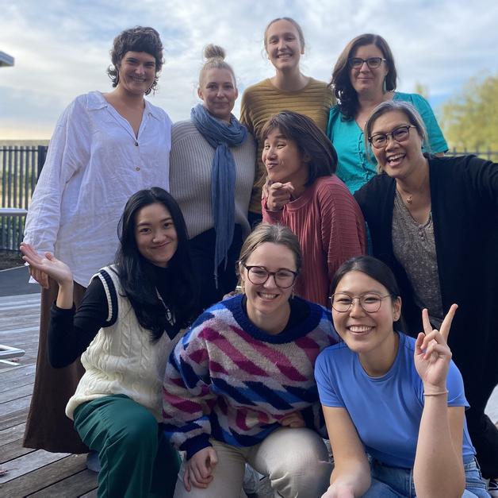

*Nine members of Southern Music Therapy, including presenters Kimberley Wade, Esther Simpson, May Clulee and Renata Kuswanto*

Four SMT Music Therapists will be presenting at the upcoming Music Therapy 50th Anniversary Conference. Kimberley Wade, Esther Simpson, May Clulee and Renata Kuswanto. Each feel extremely honoured to be presenting on home soil in September, we could not be prouder of this achievement. Our team is diverse, allowing us the ability to change and adapt to the ever- evolving industry that is Music Therapy.

We work with people as young as five to the young at heart in both of our clinic spaces (BrainTree Wellness Centre and St John of God), throughout the community as well as within multiple facilities across Canterbury, including Hōhepa Canterbury, St John of God, Brackenridge, Laura Ferguson Brain Trust and Burwood Hospital to name a few. Having one of our clinic spaces at BrainTree Wellness Centre has opened a whole new world for our team, we work closely with Dementia Canterbury, Aspire New Zealand, Multiple Sclerosis and Parkinsons (MS&P), Cantabrainers choir, Aphasia New Zealand and the stroke foundation. Southern Music Therapy has grown over the last few years but is adjusting with the ever-changing parapatry of the industry.

Renata will be sharing some of her intimate work that covers continuing music therapy care in stroke rehabilitation. We collaborate regularly with the Christchurch Symphony Orchestra (CSO) we have multiple projects we are currently working on, including our Movement to Music Group in collaboration with MS&P & the CSO. Esther will be presenting on a similar project which was completed in 2023 at Burwood hospital that perceived impacts of music therapy movement group for stroke rehabilitation viewed through the lens of hauora, a Māori model of health.

Kimberley also co-founded Cantabrainers Choir around the same time Southern Music Therapy was established. We have worked hard with the Therapeutics Choir Trust to expand the accessibility of this choir; we now have three choirs that we proudly facilitate. Senior Music Therapist May Clulee facilitates the North Canterbury Choir weekly.

May is sharing her journey of developing a bicultural supervision practice model informed by the matauranga Māori (Māori worldview) concept of kaitiakitanga (guardianship). This model was developed at a postgraduate diploma in bicultural professional supervision course at Te Wānanga O Aotearoa. She is co-presenting with her kaiako Lewis Stephens who taught on the course.

Kimberley will share the journey from graduation to establishing a large Music Therapy private practice in the South Island. She will also share some exciting new projects SMT are a part of now.

#### Session 5: Rachel Austin and Benjamin Jensen, New Zealand

When I (Rachel) was a child I spent many happy hours listening to my parents’ and older sisters’ vinyl records. As each one played, I sang or danced – completely immersed in the music – delighted and energised by the experience. My relationship with music continued into secondary school.

Ensembles and choirs were not only an avenue for musical development and expression but a place to grow friendships and belong.

At Palmerston North College of Education, music was my curriculum specialty and I was privileged to have Morva Croxson as a music education lecturer. I was also one of a small group of students in my cohort who learned about music therapy under her tutelage. Through the ensuing years of primary teaching, raising a family, early childhood teaching at Playcentre and facilitating groups for new parents, music was integral to the educational experiences I facilitated.

I also held two strong convictions: That music was for everyone, whatever their skill level; and, music held an important role in building relationships and communities. I started my Master of Music Therapy degree 27 years after my first encounters with music therapy at the College of Education. I am very grateful that the seed planted back then has had the opportunity to grow and mature. I continue to be delighted and energised by music and its role in the wellbeing of the children and families I work with.

#### Session 5: Winifred Beevers and Meghan Thamm, Australia

I met Meghan online via peer supervision sessions in 2019; we share a client and have become friends. I am looking forward to finally meeting her in real life. I’m a music therapist because I wanted to do work with people and use music. I moved from Queensland to Melbourne to study music therapy and Melbourne is now my home.

My favourite moments in sessions are when the music facilitates interactions between clients and the people around them. I see people go from silent to singing, motionless

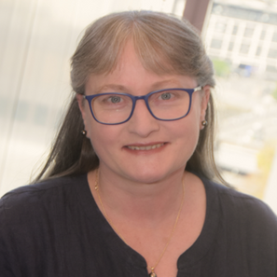

*Presenter Winifred Beevers*

to tapping small percussion, and from frowning at the floor to looking up and smiling. I play several instruments and enjoy picking up new ones. My next instrument will be the bagpipes. I use piano/keyboard, ukulele and guitar at work. My accordion comes out on VERY special occasions. I’ve been wanting to visit New Zealand for a long time and am excited to finally make it.

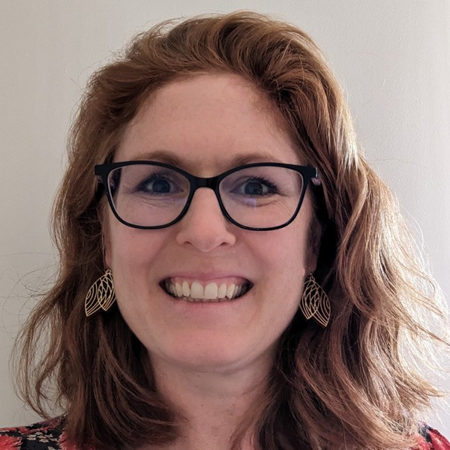I am really looking forward to presenting with my colleague and friend, Winifred Beevers, at the Music Therapy NZ 50th Anniversary Conference for a number of reasons. It will be the first time Winifred and I have met in person despite knowing each other since 2019! We meet regularly through online peer supervision and have shared a client since 2022; however, these in-person sessions have taken place from our separate locations in different states in

*Presenter Meghan Thamm*

Australia. We will be presenting on this unique situation at the conference.

I love working as a music therapist and value the unique qualities of each individual and group I work with. I have not been to NZ since a youth orchestra tour back in 1991 (I play the French Horn) and am excited that this time my husband and children will be joining me post-conference for a holiday. In our neck of the woods, Northern New South Wales, we get humid summers and mild winters so my daughter is hoping to see snow for the first time.

#### Session 6: Alison Talmage, New Zealand

My recent practice has focused on "neurological choirs" for adults with varied neurological conditions that affect their communication and socialisation - in Aotearoa New Zealand we have a model of practice that brings people together in a therapeutic choir.

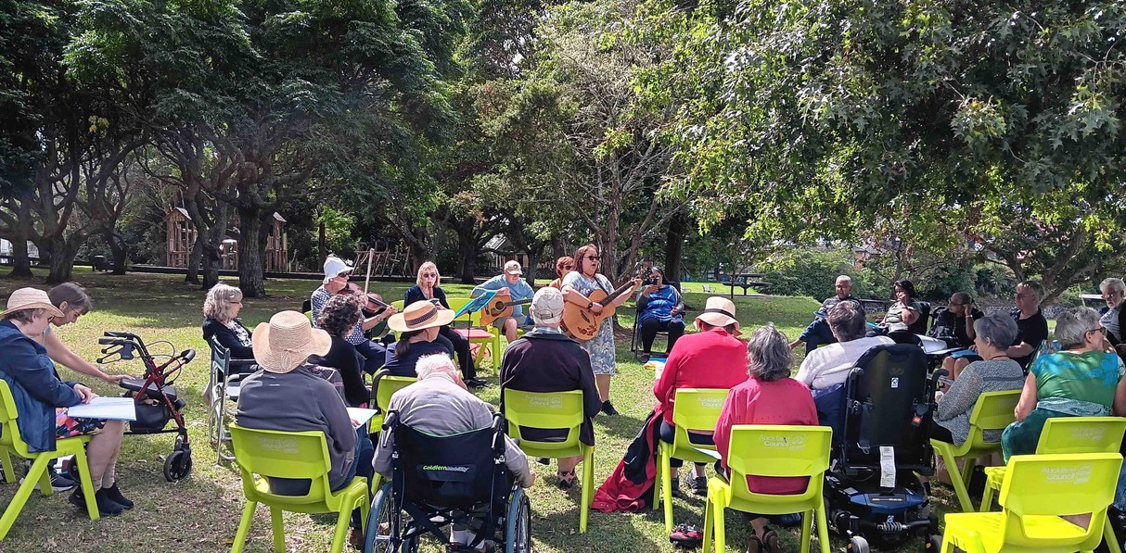

*CeleBRation Choir outdoors session and picnic, March 18, 2024,*

*Melville Pavilion, Auckland*

My PhD action research study has produced a flexible handbook for practitioners - for music therapists and our interprofessional colleagues who work in this shared field of practice. The most fun part of my practice and research is songwriting with and for the choirs and as part of a multi-media reflexive journal. My conference presentation will share an overview of my research and handbook, mainly through songs, so be prepared to sing along!

#### Session 6C, 6E, 10B and 16: Vicky Abad, Katja Enoka and Kelsey Passlow, Australia

I (Kelsey) started working as a registered music therapist in 2020, and it was a very turbulent time of change, with COVID and lockdowns significantly impacting the way I thought my career would start. The extra time to reflect on my work, however, provided an opportunity to observe how quickly the disability landscape shifted and neurodiversity affirming approaches evolved out of the population moving to share stories increasingly online. Throughout the start of my career, I have reflected heavily on how, in moving forward in life and work, the past has served as an invaluable foundation in being able to compare my learnings. I often find that when working as a music therapist, I must also serve as a bridge between different parties and stakeholders, so the past continues to hold relevance.

This experience so far made me quite excited to see the New Zealand conference theme, along with Vicky Abad and Kelsey Passlow from the Music Beat Australia team who have had similar experiences, so we just had to be a part of it. We can’t wait to come over and share in this conference and learn from our international colleagues (this will be Kelsey’s first conference presentation!).

#### Session 7B: Merrill Tanner, Canada

I have always found joy and solace in singing, even as a child, before I could speak. Later, my delight in singing led me to pursue to advanced studies in music (B & M. of Music in Voice Performance) and training in speech therapy (BSc in Speech Pathology & Audiology), both of which involved the voice and self-expression. When I began work as a speech therapist, it seemed natural to use singing, a more vigorous use of the vocal system, when treating my patients, and I was astonished by the positive effect singing therapy could have on speech, voice, swallowing, language, and coughing issues.

Those in charge of funding programs could not see the connection, so I looked for research that would corroborate what I had observed. Because the literature was not yet well developed, I began conducting my own studies on group singing that eventually led to a PhD project in Rehabilitative Science.

My research helped legitimize singing therapy in my hospital and in my community, which in turn inspired others to establish groups in other cities and countries (Australia).

These include two psychologists in eastern Canada who attended my presentations at the Advancement of Interdisciplinary Research on Singing Symposiums, and who have received funding for the SingWell Project, which promotes “group singing for people living with communication challenges” and provides international funding for graduate students who study singing treatments.

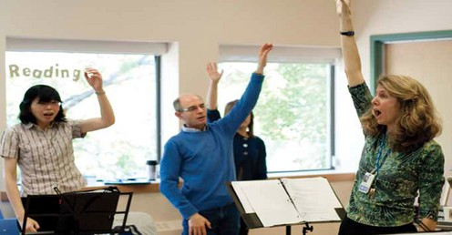

*Presenter Merrill Tanner (right) with clients*

#### Session 7: Sinead Hegarty, New Zealand

How the neurodiversity paradigm is reframing my understanding of music therapy: At the moment I am interested in amplifying the voices of neurodivergent writers leading the neurodiversity movement and considering how I can best engage as a neurotypical (meaning my neurocognitive style fits within dominant societal standards) music therapist.

Music therapist Jessica Leza is one of those voices. After hearing her recent interview on the podcast ‘music therapy conversations’ I have come to critique my own thinking on what the recently coined approach ‘neurodiversity- affirming music therapy’ means. Leza warns that superficially accepting the term ‘neurodiversity-affirming’ can disguise ways of working that perpetuate ableism and neuro-normativity in therapeutic spaces. Leza, an autistic person herself, pointed me towards another autistic author; Dr Nick Walker (she/her), who is a queer, trans, professor in somatic psychology and the creator of the neurodiversity paradigm. I recommend exploring both their work. Walker's; Neuroqueer Heresies: Notes on the Neurodiversity Paradigm, Autistic Empowerment and Postnormal Possibilities or her website neuroqueer.com offers open access essays and videos of her work and research. Leza has also published important writing on this topic in her book An introduction to Neurodiversity and Autistic Culture for (Music) Therapists and has published chapters in The Oxford Handbook of Queer and Trans Music Therapy and Sociocultural Identities in Music Therapy.

One shift in my thinking since engaging with these writers' work is my understanding of how music therapy is framed for participants. For example, autistic people make up a large proportion of music therapy participants; however it is inaccurate to say a child should have music therapy because they are autistic.

Within a neurodiversity paradigm, the autistic neurotype is viewed as a perfectly healthy way of being. However, as a result of being autistic in a world that is built for neurotypical people, it makes sense that an autistic child may experience significant distress and disablement as a result of the mismatch between their way of being/needs and society’s inability or refusal to adequately accommodate those needs.

I wonder how the purpose of music therapy might be reframed so that the focus is on addressing the impacts of this mismatch as opposed to addressing a perceived problem or deficit located within a neurodivergent individual.

Neurodiversity is a natural part of human diversity, and I wonder what we lose by depriving ourselves of embracing neurodiversity at every level of society?

Walker would say we miss out on creative synergy and the ‘genius of diversity’.

#### Fiona Hearn Fiona smiling with long blonde hair and a tree in the background, is holding a violinSession 7D: Fiona Hearn, New Zealand

*Presenter Fiona Hearn with her violin*

Kia ora! I'm Fiona Hearn, NZ RMTh, and am excited to present a poster at the upcoming conference about music therapy at MIX, a mental health community day service in Te Awa Kairangi, Hutt Valley. I am in awe of the people that I work with and want to celebrate their beautiful music and how their ideas have shaped the work over the past 17 years. I have seen first-hand how the weekly music therapy group helps participants to connect with each other and offers a collaborative, inclusive space to foster creativity and hauora (wellbeing).

Participants use the group in many creative ways including improvisation, songwriting, dance and group singing, as well as to record our music and perform at community events.

MIX's mission is to: 1) Connect individuals to form shared communities 2) Create learning opportunities in wellbeing and art 3) Live life through the '5 Ways to Wellbeing': https://mentalhealth.org.nz/five-ways-to-wellbeing

Music therapy is a modality that is able to work on all these aspects simultaneously in a meaningful and creative context. Through my work in both hospital and community mental health settings, I have seen the huge need for further music therapy provision in the community and hope that the poster communicates how music therapy can be an effective way to support tangata whai ora (people seeking wellbeing). One participant's feedback sums it up well: "Music helps calm the stress that builds up when life knocks on the door." I look forward to seeing you at the conference.

#### Session 8B: Megan Spragg, Australia

I am really excited to be coming back to New Zealand to share with my friends, colleagues and whanau a topic that is becoming more and more relevant particularly in this post covid busy, busy world. How often have you been asked – what could I do with them at home? Or could I use your song? Or how does that song meet their goals?

These repeated questions have caused me to focus more on the wider needs of both my clients and their communities which include their families, friends, carers, teachers, therapists, and other supporters. How can my music therapy sessions have a wider impact and therefore a better long-term impact for my clients or in fact for others who work with similar groups of people? This focus has allowed me to develop my practice into something quite different, challenging, and exciting and has led to some incredible opportunities for sharing about music therapy with a huge range of people all over the world.

I have been so encouraged along in this new journey of work by my clients and my colleagues and it was a client’s mum who suggested I should explore this further with you all so we can all develop our own ideas further and widen both our personal impact and the impact of music therapy in our communities.

#### Session 8D: Chris O’Connor

Here is my special moment: An afternoon with Milford Graves: In 2003 I was in New York City on a pilgrimage to see and hear and maybe even meet some of the jazz masters I had been admiring from afar, since falling in love with black music during my jazz studies at the Wellington Conservatorium in the mid-1990s.

Two such masters were saxophonist John Zorn and drummer Milford Graves, and I was beyond excited to have tickets to their duet performance. During intermission, there were lots of people coming to pay their respects to the elderly woman sitting beside me. I soon realised I was sitting next to Mrs Graves! I plucked up the courage to speak with her, and before long I had their phone number and an invitation to visit their home in Queens.

Chris O'Connor

Chris O'Connor in 2003 with a bemused expression on his face sitting behind a cymbal


*Presenter Chris O’Connor 2003*

A few days later I entered their yard on a warm spring afternoon to find Mr Graves planting a pineapple tree in his lush garden. We were soon down in his basement laboratory. The walls were lined with wooden cabinets filled with scientific instruments, shelves of drums from all over the world, a life size model skeleton, posters of cardiovascular diagrams. There were two hand painted drum kits set up facing one another. We each sat at the drums and our lesson unfolded across a wondrous afternoon.

Aside from the rhythms he initiated me into that day, and the fabulous stories he told of his meetings with jazz greats, I was struck by the profound way in which he integrated multiple practices - he was an herbalist, acupuncturist, and martial artist. Central to all of this was his deep commitment to the healing possibilities of rhythm and drumming, especially in relation to our cardiovascular system. That day opened many doors for me in my thinking around music, and was instrumental in me pursing music therapy decades later. Mr Graves passed away in 2021. I'd recommend watching the documentary called Full Mantis, all about his life and work. You'll see his lab, the very one I visited!

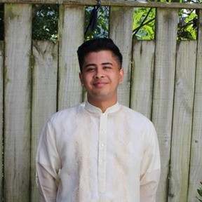

*Presenter TJ Hernandez*

#### Session 9: TJ Hernandez

My presentation is inspired by the research I did in my final year of my music therapy study. During this time, I explored how my intersectional identities manifested in and around music therapy spaces. There was a particular focus on my cultural identity as a first-generation/ Aotearoa born Filipino and how I navigated racial microaggressions whilst working in aged-care facilities. In addition to this, my identity as a non-disabled, neurotypical, young male afforded me with a lot of power.

It was challenging learning how to navigate these contradicting experiences, but in the end, I leant so much about myself and how to move forward.

With this presentation, I feel excited to share a cultural experience that is not well documented in Aotearoa or in music therapy spaces broadly, and hope to contribute to the conversations already being had around social justice and anti-oppression!

*Presenter*

#### Headshot of Matthew Breaden

#### Session 9D: Matthew Breaden, Australia

I am delighted to be presenting a workshop at the 2024 MThNZ conference. I feel honoured to have been selected to present, but I know I have also been very fortunate in my life and career to have been given the opportunities and support to get to where I am now. Music therapy has opened many doors for me, and I want to help open doors for others.

*Matthew Breaden*

So my aim in my presentation is that those attending can gain new techniques, ideas, and inspiration for their practice. Figurenotes is annotation system which has opened new doors for me in my work as a music therapist and researcher. It makes playing music so accessible. And while we can certainly learn and gather much from online

resources, there’s nothing like in-person experiences to really share and impart knowledge. So I’m very excited to present a Figurenotes workshop at this year’s conference!

Here is a story I’d like to share about my experiences with one client and Figurenotes: Noel is a young man with an intellectual disability. He started music therapy because he really wanted to use music more in his life, as a way to regulate his emotions, but also as a means of self-expression and to connect with others. He loved music, and wanted to play his favourite songs on the keyboard. But there was a problem. Despite all our efforts, traditional music notation just didn’t work for him. He wanted to be able to read the music, as he was a visual person.

But we’d hit a brick wall.

I researched the options, and found Figurenotes had been developed in Finland and was being used with success there. So I travelled to Finland and met the creators. When I returned to Australia I tried it out with Noel. And guess what? In the first session he was already playing one of his favourite songs, “Stairway to Heaven”. This was a big smile moment, and there have since been many more!

#### Session 10: Emma Matthews, New Zealand

I have been working in the education sector for the majority of my

career - although I have experience in dementia care, and have other areas of interest that I would like to explore one day. I live and work in the beautiful Nelson/Tasman region with my husband, children, and pets.

My presentation will cover my career as a music therapist working in specialist education. I will focus on the more recent career move to provide music therapy services, session, and presentations to music teachers, educators,

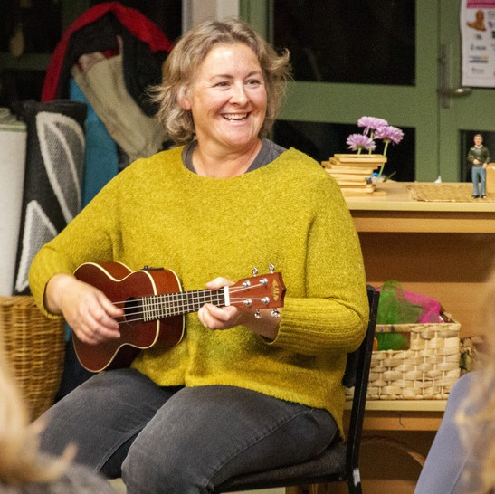

*Presenter Emma Matthews playing a ukulele to children*

kaiako and tamariki - initially with work in Invercargill and then

Nelson/Tasman. This is a real 'hybrid' model of working, and the result of some practical problem solving - being busy, negotiating having a bit of a case of imposter syndrome and a pinch of geographical isolation. This period of growth was hugely rewarding to my career and my connection with my community, and I would love to share how it all unfolded (and share some songs that were created along the way).

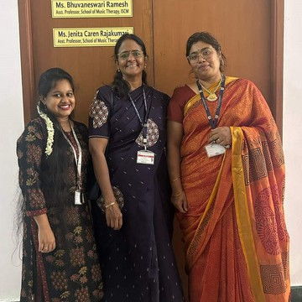

*Presenters Sobana Jaiganesh,Bhuvaneswari Ramesh and Jenita Caren Tajakumari in front of the Faculty Room*

#### Session 10C: Sobana Jaiganesh, Bhuvaneswari Ramesh, and Jenita Caren Tajakumari, India

The team from the School of Music Therapy (SMT), Institute of Salutogenesis and Complementary Medicine is an amalgamation of three music therapy academicians / researchers with a background in various fields. Prof. Sobana is a Medical doctor and Physiologist with a career in medical simulation as well. She is currently the Administrative in Charge of SMT, mentoring the students and faculty.

Mrs. Bhuvaneswari Ramesh is an Assistant Professor and PhD Scholar who has a background in Business Administration. She is also the current South-East Asian Regional Liaison at the World Federation of Music Therapy.

Ms. Jenita Caren who is also an Assistant Professor at the School of Music Therapy is a Speech Language Pathologist and Medical Music Therapist. She also represents South East Asia in the Publications commission of the World Federation of Music Therapy.

These three Music Therapists of various backgrounds balance and support each other as a team carrying out patient care, music therapy research and training. Music therapy is a very novel profession in the current Indian scenario and thus, advocacy of the true virtues of the profession is significant. The team aims to advocate music therapy within the Indian subcontinent and also spread the word of the uniqueness of music therapy in India across the globe. Working in a medical university, the team has access to various clinical areas within the hospital and a wide range of community areas in and around the Puducherry state. The School of Music Therapy, Institute of Salutogenesis and Complementary Medicine is a constituent institution of the Medical University SriBalajiVidhyapeeth at Puducherry, South India.

#### Session 13: Elizabeth Coombes and Beth Pickard, Wales, UK

Why should music therapy training be accessible only to those with certain and significant privileges? With revalidation required for our part- time MA Music Therapy at the University of South Wales in the UK we saw an opportunity to reframe this postgraduate course. We wanted to challenge the potential barriers to training as a music therapist which have been identified in contemporary discourse (such as the British Association of Music Therapy’s Diversity Report, 2020; and our own research into UK musicians perceptions of the training routes into music therapy, Bradbury et al, 2021).

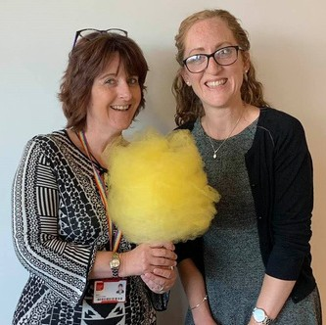

*Presenters Elizabeth Coombes (left) and Beth Pickard (right)*

These barriers include education, time, finance, disability, geography and many more. In an endeavour to address these challenges, through consultation and collaboration with students, graduates and colleagues, we have invigorated the MA Music Therapy at the University of South Wales.

Key developments include devising a programme that is currently the only blended music therapy training in the UK. This enables students from a wider geographical and socio-economic context to access training, and also minimises financial impact by reducing travel costs and personal therapy requirements and enabling more flexible working and caring responsibilities around the programme.

We have pursued inclusion by design and held accessibility as a core focus of the teaching, centring and valuing the lived experiences of students as valuable assets for the future profession. A focus on contemporary music therapy skills and practice enables students with a wide range of musical backgrounds and trainings to contribute meaningfully to the rich learning experience. We look forward to sharing our innovative approach to contemporary music therapy pedagogy at the conference, and exploring with you the challenges and opportunities this has afforded.

#### Hilary Baxter Headshot of Hilary Baxter with greenery in the background Session 14D: Hilary Baxter, Australia

*Presenter Hilary Baxter*

I remember learning about music therapy in a careers class in high school. I was struggling as I thought I wasn't good at anything and there couldn't possibly be a career for me! While looking in a huge book that listed all the careers you could have, I came across music therapy.

One google search later and I was hooked; I knew what I wanted to do 'when I grew up'.

Ten years later, I graduated as a music therapist and was in shock that I actually did what I set out to do as a 16 year old. It's been a fun, stretching, and eye-opening experience the last few years working in the field and I'm looking forward to all the ones to come! I'm very excited to be presenting at the conference and am honoured to share a case study about one of my first clients.

#### Session 13C and 17A: Oliver O’Reilly, Australia

Hello everyone!!! My name’s Oli, I’m excited to attend my first music therapy conference in New Zealand, and honoured to participate in the celebration of this magnificent milestone of 50 years of MTNZ.

Growing up on the fringes of Sydney without access to music lessons, I fumbled my way around the sax and piano and gradually pieced things together. I was simultaneously compelled to play at every opportunity, yet petrified that I would be exposed as a fake musician.

This eventually led me to studying music therapy and then going on to embarking on a PhD where I explored how we learn to connect musically, especially when our first instrument isn’t available. I am very pleased to have had two papers accepted for this conference that look backwards and look forward in my own career as a music therapist. My first paper is an autoethnographic account of my journey to accepting my identity as a real musician.

My second paper reports the key findings of my PhD where I developed and tested a professional development program to support piano-based music therapists adapt their music skills to flexible and responsive use of the guitar in therapeutic settings.

Jenny Gordon

Jenny in bright green jersey and blue scarf with square glasses holding a ukulele and looking happy


*Presenter Jenny Gordon*

*playing the ukulele*

#### Session 15: Jenny Gordon, New Zealand

I came for the activity. I stayed for the people. The RGM activity piqued my initial interest but it is the people I met through the course of that activity, and our shared passion for it, that have added the most value to my life. The activity is very interesting and intricate in many ways but it does not compare to the boundless variety of information and opportunities that are possible arising from the people I have met through RGM.

RGM is a structured, cognitive and movement exercise method using rhythm and music as stimuli. It involves decoding words and symbols

denoting actions or movements, speaking the appropriate word whilst simultaneously completing the action using music as a source of beat and rhythm.

The people who have impacted me through RGM are the creator of the method, Ronnie Gardiner – legendary jazz drummer living in Sweden – and his two long-time collaborators and RGM master-trainers, Dutch couple Mariken Jaspers and André de Jong. The three of them came to Aotearoa New Zealand in 2019 to conduct a series of trainings around the motu. They came after Professor Ngaire Kerse, the Joyce Cook Chair in Aging Well (University of Auckland), had spent six years ‘spreading the word’ to build a network of potential trainees, and securing funding, having seen an RGM talk in Europe, followed by a 2-day training in London, whilst she was on sabatical in 2013. Just these four individuals alone are enough to impact my life substantially. But wait ... there’s more!

There is a group of individuals that trained in 2019 when I did and some of us have met regularly in the intervening years, working on ways to run trainings for RGM in Aotearoa, heavily impacted by Covid-19. We are all working in industries that might be termed health and wellbeing related but we are all differently skilled and have much to share with each other. These people include Professor Ngaire Kerse, noted above; the President of NZ Society of Diversional and Recreational Therapy (who is a member of the RT International Network); two fitness and exercise professionals who specialise in working with people with neurological conditions, cancers, and age-related problems; and one with a PhD in neuroscience. While we have very varied and interesting RGM-related conversations sharing and supporting each other with our own expertise, we also get on well on a personal level.

Further to this there have been about 140 people that have completed one or both weekend trainings to become a Certified RGM Practitioner. For many of the trainings I was one of the trainers. A large proportion of these are people who work in the aged-care sector, predominantly rest homes and care centres, and community-based programmes such as those run by Aged Concern.

Other careers include exercise professionals, conductive educators, music therapists, and physiotherapists. One man drives trains in north Sydney during the week and would like to run activities retreats for young people with disabilities in the future. Some of us meet online every now and again to share and learn through others’ experiences.

In May 2022 I was lucky enough to ‘represent’ the NZ RGM team in Sweden at a gathering to meet, share, discuss, and generally further the cause of RGM internationally. Sixteen people from 11 countries, all actively using RGM in their work to consider ways to keep the method consistent globally amongst other things. This group included Ronnie and the Dutch master-trainers, and encompassed researchers from Gothenburg University, Conductive Education Specialists and Special School Educators, Music therapists – some with PhDs in the field, a Neuro-physiotherapist, Exercise professionals, physiotherapists, Speech Language and Occupational Therapists. This was a wonderful four-day sojourn in the Swedish countryside discussing something I have grown passionate about with such energetic and passionate people. Much to learn and share – and we did!

Finally, once a week I facilitate a one-hour session for a group of people living independently in a large retirement village. I started this group early 2020 and while it was hampered by the Covid-19 lockdowns, it has continued to grow steadily with little rate of attrition once people decided ‘RGM is for them’. The group has a diverse range of individual needs, abilities, and interests, and come from a variety of careers and backgrounds. There have been lovely connections made through this group and these do seem to extend beyond the session time into the wider village life. They are quite simply the nicest bunch of people to spend an hour or so with each week and I think they feel the same.

We enjoy the cognitive work out and the camaraderie.

I absolutely believe in this method as a useful tool in my music therapy kete, but I am also very grateful for the friendships and learning relationships that I have made whilst on my RGM journey. RGM Aotearoa NZ wish to thank The Hope Foundation, University of Auckland, Physiotherapy NZ, and RGM Netherlands for their support.

#### Session 15B: Emily Wills and Jonathan Williams

Reflecting on a Duet: (This account uses pseudonyms chosen by our clients) Ahead of our presentation at the 50th Anniversary Conference, we are writing to share a brief reflection on a collaborative clinical situation. Emily’s client, Samantha, had worked on gaining confidence for almost two years. Having made consistent progress on this goal, Samantha seemed ready for a new challenge.

During this time, Jonathan had a client, Luna, whose progress suggested she may be ready to end music therapy. Seeing an opportunity to offer Luna a leadership role, while providing a new social experience for both, we decided to offer them a paired session. Both music therapy participants had been working on piano playing, so that became our point of entry. Fortunately, Samantha was able to keep her individual session with Emily during this time. This allowed Samantha, who was still reluctant to play piano in front of others, to practice with Emily and then challenge herself to play in sessions with Jonathan and Luna.

Emily and Samantha started with “Heart and Soul,” the classic duet which Samantha then successfully played with Luna. They seemed to have great fun doing this, especially when using the “screaming” setting on the electric piano. Watching Samantha and Luna’s uninhibited laughter, it was hard to imagine that just weeks before, Samantha seemed nervous to play with Emily.

Following this success, Jonathan decided to suggest the song “Golden Hour,” a hit with clients their age, but a significant step up in difficulty, even in two parts. Jonathan was amazed at Samantha, who showed no discernible self- consciousness, as she and Luna went right to work. It was wonderful to see the fast progress they made on the song, but the ease with which they took up this joint task gave something of what feels like music therapy’s essence.

In other words, it is not so much the musical outcome, but more that they did not seem to mind what the outcome would be. This account illustrates what we have often seen to be true in music therapy: Collaboration is well worth the effort when it improves the experience we offer our clients.

**Session 15C: Carlos Riegelhaupt-Landreani** During my first year of training in music therapy I came across a paper by Dr Helen Bonny and Walter Pahnke titled "The Use of Music in Psychedelic (LSD) Psychotherapy" (Bonny, Pahnke, 1972). Finding this article sparked my curiosity to learn more about the use of music in psychedelic-assisted therapy (PAT), and subsequently after a few years of working in mental health settings I enrolled in a year-long training in PAT through MAPS (Multidisciplinary Association for Psychedelic Studies) and IPI (Integrative Psychiatry Institute) in Boulder, Colorado, USA.

Carlos Riegelhaupt Landreani

Presenter Carlos standing in front of water with a blurred background


*Presenter Carlos Riegelhaupt Landreani*

While the role of music in PAT is well established as a valuable therapeutic adjuvant in dosing sessions, during my training there was little mention about the use of music and only one lecture out of well over a hundred focused on this topic. Similarly, I was surprised when

attending the Psychedelic Science Conference in Denver 2023 - out of hundreds of presentations there was only one that spoke into the role of music in PAT. This motivated me to offer informative presentations at mainstream music festivals about psychedelics in therapy with a focus on harm-reduction, and from a music therapy lens. I am thrilled to have the opportunity to present this emerging topic at the New Zealand Music Therapy Conference 2024.

#### Session 16C: Okiko Ishihara

Congratulations on the 50th anniversary. I appreciate being allowed to present and participate in such a special conference. I trained as a music therapist at the Guildhall School of Music and Drama in the UK (completed in 2001). The Head of the Music Therapy Department at that time was Dr Sarah Hoskyns. I also had the opportunity to meet music therapists from New Zealand at the World Congress of Music Therapy, who informed me about the 50th anniversary of your conference.

Music therapy in Japan has developed over the past 20 years since I returned from the UK, but there are still many challenges. I believe that learning about the development of music therapy in New Zealand and its diverse culture will give me hints for accepting diverse needs and thinking about music therapy in my country in the future. I am also very interested in New Zealand, as I have never been there.

Japan is an island nation with an original culture, and I feel that there may be something in common with the culture that New Zealand has developed as an island nation as well. I wish the conference a great success, and I am looking forward to learning new things and interacting with new people.

Okiko Ishihara Dip. M.A. MT. PhD.

Farhana Rizaini

Presenter Farhana smiling and holding a guitar and standing in front of a building with shrubs


#### Session 17C Farhana Rizaini

Being a music therapist is fulfilling my dream of working with children and serving the community through music. Every day I find so much joy in doing music therapy work and learnt to trust the process in challenging times.

Earlier this year, I also had the opportunity to present my music therapy work at the Developmental Paediatrics Conference and Early Intervention Conference in Singapore.

*Presenter Farhana Rizaini holding a guitar*

While I would love to be at Music Therapy New Zealand's Conference in person, I am still brimming with excitement to be a part of the exciting line up, and virtually being amongst familiar names - some of whom being my classmates whom I have not heard from in 6 years!

#### Session 17D: Madhurima Banerjee

I would like to share my journey that led me to pursue a career in music therapy. From a young age, I immersed myself in the world of music, particularly through learning the violin. Initially, my aspirations leaned towards becoming a Hindustani classical performer. However, as I matured, my interests expanded to include psychology. Balancing these passions became a challenge as I navigated through my academic and personal endeavours.

It was during this exploration that I stumbled upon the concept of music therapy. Suddenly, everything clicked into place. There was an avenue where I could seamlessly meld my love for music with my fascination for psychology, all while making a meaningful difference in the lives of others. Although transitioning from a music-oriented background to immersing myself in the realms of physiology, psychology, and medical terminology furthermore actively engaging in hospital settings was undoubtedly a challenging journey.

Music Therapy became the bridge that connected my passion with purpose. And lovely moments like when the clients smile brightly, mentioning it was the first time they'd smiled in ages make the struggle worth it.

#### INVITATION TO SUBMIT CONTRIBUTIONS FOR 2025 NZJMT

The 2025 No 23 issue of the Journal will include contributions from conference as well as other articles. is a peer-reviewed open access journal published annually by MThNZ and you are invited to submit original material by the closing date of 1 April 2025. The website contains further information. The editors can be contacted at: [journal@musictherapy.org.nz](mailto:journal@musictherapy.org.nz)

#### The New Zealand Journal of Music Therapy (NZJMT): NEW EDITORIAL TEAM

The New Zealand Journal of Music Therapy, in the current peer-reviewed form, has provided a unique perspective on Music Therapy in New Zealand since 2003. Previous editors include Sarah Hoskyns, Karen Twyford, Natalie Nugent, Penny Warren and Barbara Mabbett.

In 2024, as we look back at 50 years of Music Therapy and celebrate our trailblazers, we acknowledge the work of these previous editors, and especially the hard work and dedication of outgoing editors Alison Talmage and May Bee Choo Clulee.

Looking forward, we would like to introduce the new editorial team for the NZJMT: Emily Langlois Hunt and Hyunah Cho.

**Dr Emily Langlois Hunt** is Director, Founder and NZ RMTh at the Little Musical Caravan, a mobile music therapy service with a growing team, based in Porirua. Emily joins the team with experience as an author (with publications in the fields of Theology and Music Therapy) and more recently as a Language Consultant for Approaches: An Interdisciplinary Journal of Music Therapy, and Copy Editor for Voices: A World Forum for Music Therapy.

Emily stands in front of the Little Musical Caravan holding a guitar


*Co-Editor Emily Langlois Hunt in front of the Little Musical Caravan*

She also has experience of supporting writers for whom English is not a first language. She is passionate about inclusion, social justice and anti-oppressive practice and is excited for this new role with the Journal.

**Dr Hyunah Cho** is a registered

music therapist in New Zealand and South Korea, now lecturing at the University of Leeds, UK. Hyunah joins the team with her research interest in an inclusive understanding of people’s therapeutic experiences within various cultures. Cultural diversity in healing practices is becoming increasingly crucial in diverse, cosmopolitan societies to understand a ‘person as a culture’. Hyunah is keen to diversify and enhance inclusivity within the Journal, empowering a myriad of voices to be heard.

Hyunah crouches down in a field of wild flowers with a row of brick terraced houses behind.


*Co-Editor Hyunah Cho enjoying the UK summer*

We extend a warm invitation to contribute to the NZJMT, encompassing a diverse range of submissions. We welcome practice-based, research and theoretical articles, as well as community voices and book reviews. We aim to offer a platform that showcases a spectrum of research approaches and topics, fostering greater awareness of music therapy and related disciplines within the broader community.

In addition to traditional formats, we welcome alternative presentation styles such as video/audio ethnography and various art forms. We believe in the power of diverse mediums to enrich our understanding and appreciation of music therapy. Submit your article to expand the boundaries of knowledge and enhance music therapy practice in New Zealand through your valuable contributions.

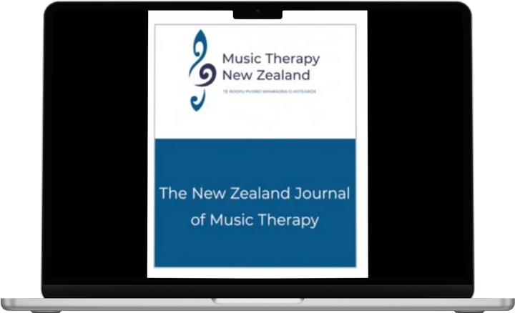

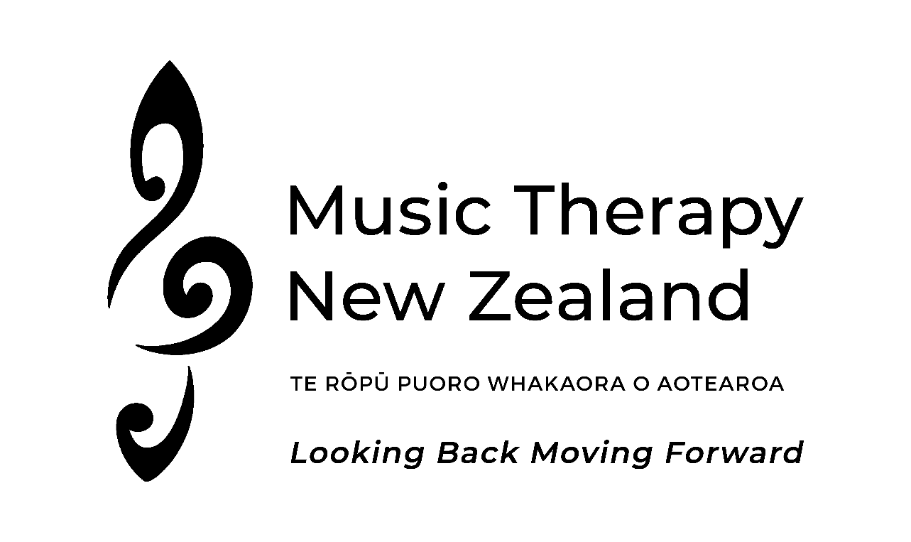



**Sponsorship Prospectus**

**13 - 15 September 2024**

Wellington, New Zealand

## www.musictherapy .org.nz

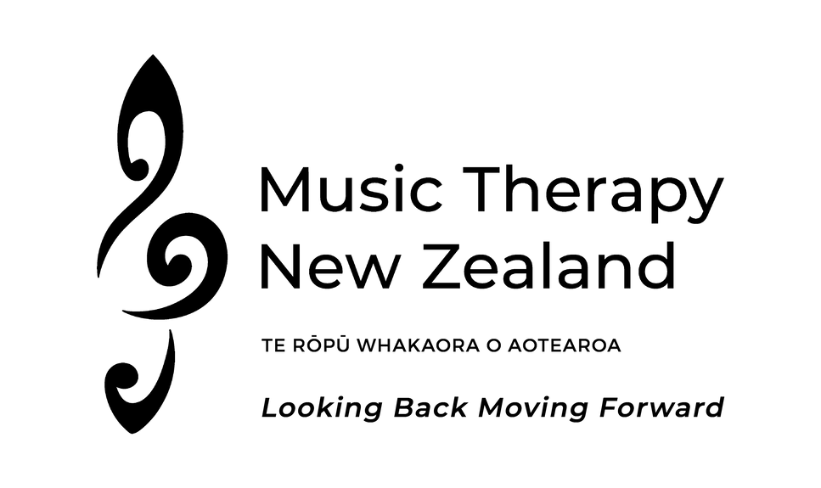

This year Music Therapy New Zealand is celebrating 50 years of Music Therapy in Aotearoa, New Zealand, with the theme of ‘Looking Back Moving Forward’. The Anniversary Celebration begins on Friday evening in the Hunter Council Chamber at Te Herenga Waka Victoria University, to celebrate this milestone as well as 20 years of the Master of Music Therapy programme. Music Therapy New Zealand’s two-day hybrid (online and in-person) conference is on the Saturday and Sunday at Te Wharewaka Function Centre, on the Wellington waterfront. The programme includes over 60 local and international presenters.

The 50th Anniversary Conference is an opportunity for sponsors and supporters of music therapy in Aotearoa New Zealand to reach your customers and the wider community. By partnering with us, you contribute towards the promotion and growth of music therapy, which brings so much positivity and improved wellbeing to so many.

We are offering a range of sponsorship opportunities and are very happy to discuss options to suit your requirements and budget.

Thank you for taking the time to consider what is on offer. Please contact us at [info@musictherapy.org.nz](mailto:info@musictherapy.org.nz) if you wish to discuss opportunities or require any information regarding participating as a supporter of the event.

**INVITATION FOR**

SPONSORSHIP

Options - package to be negotiated

$$ guideline

|  |  |
| --- | --- |
| Contribution towards $20,000 cost of conference hybrid format | $$ |
| Headline sponsor 13 th to 15 th September (for 3 days) | 5000 |
| Key-note address for Day 1 or Day 2 | 2000 |
| Morning sessions or afternoon sessions | 1000 |
| Individual conference session | 350 |
| Lunch Conference Day 1 or Day 2 | 1000 |
| Morning or afternoon tea break | 500 |
| 50 th Anniversary history video | 1000 |
| Sponsor student/concession attendee registration | 200 |
| Other suggestions welcomed | $$ |

“*Yesterday was one of the most rewarding, when we had a visit from a Music Therapist. What a great experience. To see a whole group of residents joining in by either singing, requesting, conversing or playing an instrument was a very emotional experience. The communication between residents wasgreat and it was obvious how well they responded…” (Family Member)*

|  |  |  |
| --- | --- | --- |
| Exhibition space (Mākaro room) |  | |
| Space | 1 day | 2 day |
| Full trestle table 1.8m | 200 | 300 |
| Half shared trestle table | 150 | 175 |
| Small square table or high-leaner table (900mm) | 125 | 150 |



SPONSORSHIP

All sponsors and donors will be acknowledged for their

generosity and support for making the 50th Anniversary Conference celebration a rich history of the birth and growth of music therapy in

New Zealand.

Contact the Executive Officer, Sarah Cole for further discussion at [info@musictherapy.org.nz](mailto:info@musictherapy.org.nz) or

+64 20 499 2327 .

*“Mum has dementia however I have noticed improvements in her cognitive function since she started her (music therapy) sessions..” (Family Member)*

*“Music Therapy has not only brought our daughter great improvements in motor planning, finger*

*strength, communication and attention span, it has brought her great joy as well. There is no place*

*she would rather be than in a room making music” (John and Emma, Hamilton)*

*“We feel privileged to be part of these groups and to witness the transformation that these sessions*

*bring about…extremely moving and powerful…Music Therapy is priceless”*

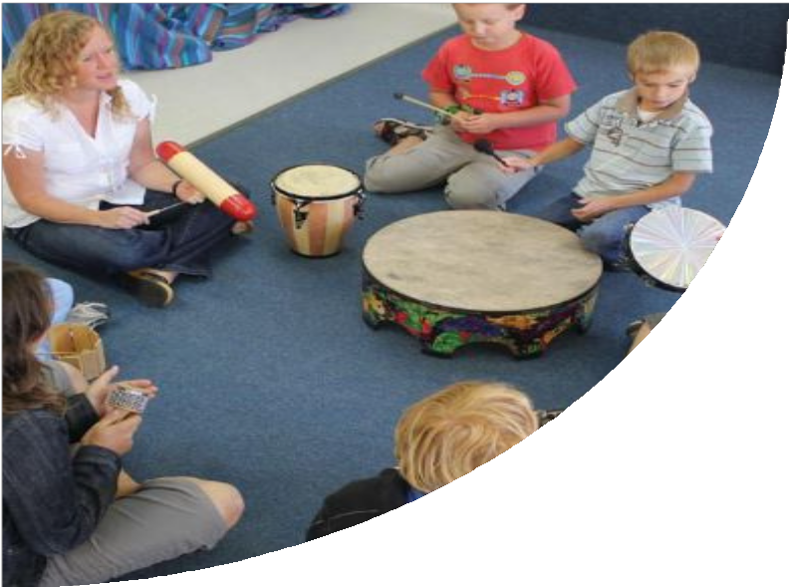

**ABOUT**

MUSIC THERAPY NEW ZEALAND

TE RŌPŪ PUORO WHAKAORA O AOTEAROA

Our key objectives are to:

1. Raise awareness and understanding of music therapy;
2. Advance the provision of music therapy to all who will benefit from these services;
3. Maintain standards of ethical practice to protect the safety of all clients;
4. Advance research of music therapy in a range of settings, including the health and education sectors;
5. Provide funding for study, research and activities that aim to advance the provision of music therapy in specific areas where there is an identified need; and
6. Develop relationships with relevant stakeholders.

The objects of the Society shall reflect the cultural diversity of New Zealand and have due regard to Te Tiriti O Waitangi (The Treaty of Waitangi).

https://www.musictherapy .org.nz/